

FACULTY OF ENGINEERING AND THE BUILT ENVIRONMENT

DEPARTMENT OF ELECTRICAL ENGINEERING TECHNOLOGY

Ramolatela Lebaea

221064591

NETWORKS 2B

LAN CABLE CONSTRUCTION

September 2023

Dr. A. Alonge

Table of Contents

1. INTRODUCTION 2
   1. Objectives 2
2. APPARATUS 2
3. PICTURES OF CABLES AND DISCUSSION OF RESULTS 3
4. CONCLUSION 4
5. REFERENCES 5

Table of Figures

Figure 1: Straight Through 3

Figure 2: Cross-Over Cable 3

# INTRODUCTION

## Objectives

The main goals of this lab are to:

* + - Gain more knowledge and skill to create a CAT-5e straight-through UTP cable.
    - Acquire the knowledge to build a CAT-5e cross-over UTP cable.
    - Grasp the distinctions between the two TIA/EIA twisted pair cabling standards, namely: 568A and 568B.

What is the difference between UTP and STP?

Unshielded Twisted Pair(UTP) is a type of twisted pair cable commonly employed for transmitting both data and voice signals due to its suitable frequency range. Its cost- effectiveness, low maintenance requirements, and lack of a need for a grounding connection make it an economical choice.**[1]**.

Shielded Twisted Pair(STP) is another type of twisted pair cable. Unlike UTP, STP requires a grounding cable. In Shielded Twisted Pair (STP), it demands a higher level of maintenance, making it a more expensive option compared to Unshielded Twisted Pair (UTP).**[1]**.

# APPARATUS

* 2× 1 meter UTP cable
* 4× RJ 45 plugs
* Crimper
* Side cutter

# PICTURES OF CABLES AND DISCUSSION OF RESULTS

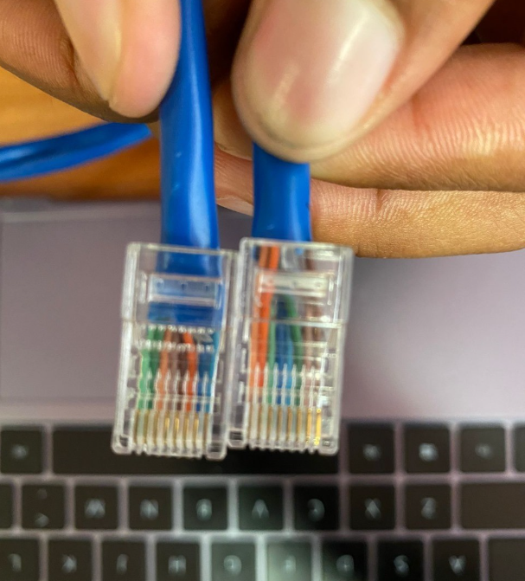

*Figure 1: Straight Through*

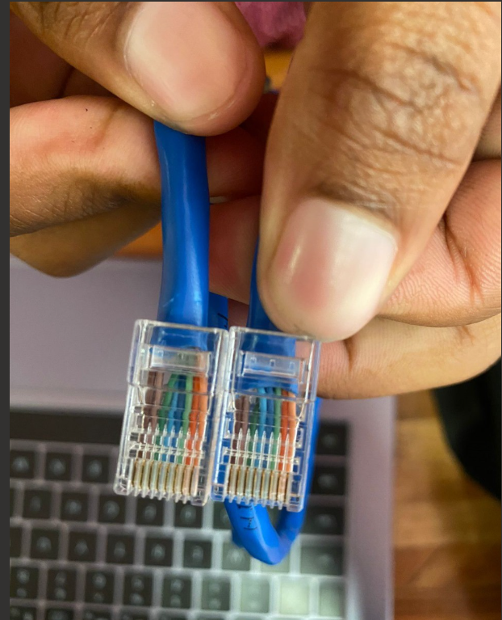

*Figure 2: Cross-Over Cable*

In a straight-through cable, the wires are connected from wire 1 to wire 1, wire 2 to wire 2, and so on up to wire 8 to wire 8. Straight-through cables are employed when connecting dissimilar devices, like a desktop and a router, to ensure proper communication.

On the other hand, in a cross-over cable, the wiring is different: wire 1 is connected to wire 3, wire 2 to wire 6, and so on (1-3, 2-6, 3-1, 4-7, 5-8, 6-2, 7-4, 8-5). This type of cable is used to connect similar devices, such as desktops to desktops or hubs to hubs.

# CONCLUSION

In conclusion, this lab focused on CAT-5e UTP cable construction, covering the creation of both straight-through and cross-over cables. Essential skills in crimping were acquired during this hands-on experience. The project also highlighted the differences between UTP and STP cables, emphasizing the cost-effectiveness of UTP and the grounding requirement of STP.

This lab was really useful because I learned how to use the crimping tool. Now, I also know where UTP and STP cables are used in different industries. We mainly followed the T568B wiring standard, which is the most common one.

# REFERENCES

1. Geeksforgeeks. (n.d). *Difference between Unshielded Twisted Pair (UTP) and Shielded Twisted Pair (STP) cables*. Available from:

[https://www.geeksforgeeks.org/difference-between-unshielded-twisted-pair-](https://www.geeksforgeeks.org/difference-between-unshielded-twisted-pair-utp-and-shielded-twisted-pair-stp-cables/) [utp-and-shielded-twisted-pair-stp-cables/](https://www.geeksforgeeks.org/difference-between-unshielded-twisted-pair-utp-and-shielded-twisted-pair-stp-cables/) [Accessed 17 October 2023].